**Exercise 1**

**Preparation for Exercise 1**

You will need to download the code from the **Lesson 6 Workshop** and save it on D:\ drive

Open the folder using Visual Studio code.

When you are in the Visual Studio code, open the terminal window by selecting from the top menu **Terminal** --> New **Terminal**

On the terminal type: **npm install**

**This command will install all the dependencies that we have specified on the package.json**

**Building your project**

When we run **npm run webpack,** we are running a webpack procedure where we are grabbing all the src files together with the libraries and placing them together in one file.

**Running your project**

Note: we need to run **npm install http-server**

Once we build our project, we can run a local server by running **npm run start** that runs a local webserver

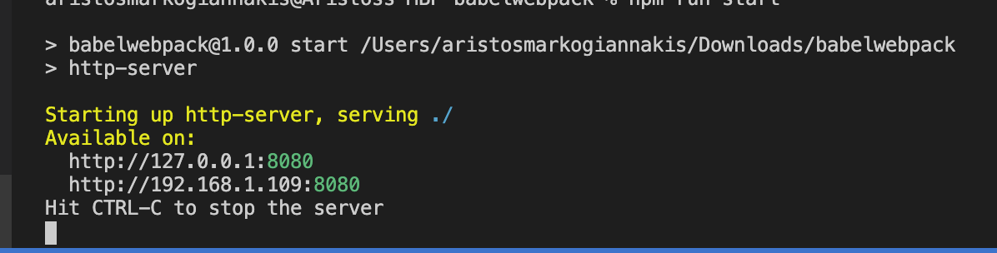

You can then load the website on <http://127.0.0.1:8080>

Once loaded you will be able to see a blank page with a title “First es6”.

Right click on the page and Inspect Element - Open the console.

You should be able to see in the console.

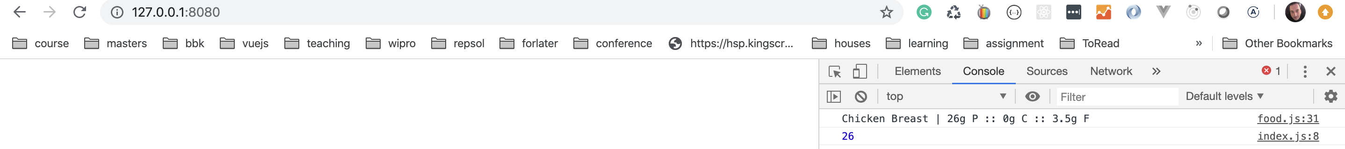

**Exercise 1: Building a subclass**

Once you have the same app working as my presentation, we are going to add another one

**Step 1:**

Inside the app folder create a new file called FatFreeFood

**Step 2:**

Copy the code below (Please do not copy past, type the code)

|  |
| --- |
| "use strict";  import Food from ‘./Food.js’    // FatFreeFood is a derived class  export class FatFreeFood extends Food {  constructor(name, protein, carbs) {  super(name, protein, carbs, 0);  }    print() {  super.print();  console.log(`Would you look at that -- ${this.name} has no fat!`);  }  } |
|  |

**Step 3:**

**Now you will need to add the following code to our index.js**

|  |
| --- |
| import { FatFreeFood} from './app/fatfreefood.js'  **//Beginning of the code**  **const fat_free_yogurt = new FatFreeFood('Greek Yogurt', 16, 12);**  **fat_free_yogurt.print();** |

**Run npm run webpack. And refresh your webpage.**

**Questions:**

1. What does it mean byFatFreeFood extends Food what does this do?
2. What does the super does?

**Exercise 2**

You will need to download the second workshop “Jest ES6 Workshop” in Moodle and save on the D:\ drive on your desktop.

Using Visual studio code open the folder “es6tdd-master”.

From the top menu you will need to load the console/terminal on the Visual Studio code.

**Step 1:**

To initialise the code you will need to run **npm install**

This will install all the node_modules and the libraries used to run the code we will run with the testing

**Step 2:**

We will go through the code that is already written and modify to make it work.

You will need to go through the files in the order they are named 01 to 02 to 03 and when you change the code you will need to run on the code

**npm run test**